

American International University-Bangladesh (AIUB)  
**Department of Computer Science  
Faculty of Science & Technology (FST)**

**NextGen Online Shopping**

A Software Requirement Engineering Project Submitted

By

|  |  |  |  |  |
| --- | --- | --- | --- | --- |
| **Semester: SPRING_23_24** | | **Section: D** | **Group Number: 09** | |
| SN | Student Name | Student ID | Contribution in % (CO+CO2) | Individual Marks |
| 10 | TARIKUL ISLAM | 20-43662-2 | 5% |  |
| 11 | SADIA ISLAM TRISHA | 20-43664-2 | 40% |  |
| 26 | S M SHAMSUL ARFIN | 21-45053-2 | 25% |  |
| 38 | MD. SHARIF RAYHAN | 19-41156-2 | 30% |  |
|  |  |  |  |  |

The project will be Evaluated for the following Course Outcomes

|  |  |  |
| --- | --- | --- |
| **EVALUATION CRITERIA** | Total Marks (50) | |
|  | |
| Introduction, Format, Submission, Defense | [10 Marks] |  |
| System Overall Description & Functional Requirements | [10 Marks] |  |
| System Quality Attributes and Project Requirements | [10 Marks] |  |
| UML and E-R Diagram with Data Dictionary | [10 Marks] |  |
| UI/UX Prototyping | [10 Marks] |  |

Software Requirements Specification

for

NextGen Online Shopping

Version 1.0 approved

Prepared by

SADIA ISLAM TRISHA

S M SHAMSUL ARFIN

MD. SHARIF RAYHAN

American International University - Bangladesh (AIUB)

10/05/2024

Table of Contents

Revision History 3

1. Introduction 4

1.1 Purpose 4

1.2 Document Conventions 4

1.3 Intended Audience and Reading Suggestions 5

1.4 References 5

2. Overall Description 5

3. System Requirements 7

3.1 System Features 7

3.2 Non-Functional/Quality Requirements 11

3.3 Project Requirements 11

4. Design and Interface Requirements 13

4.1 UML Diagrams 13

4.2 Data Dictionary 15

4.3 UI/UX Design Specification 16

# Revision History

|  |  |  |  |
| --- | --- | --- | --- |
| **Name** | **Date** | **Reason for Changes** | **Version** |
|  |  |  |  |
|  |  |  |  |

# Introduction

## Purpose

* The idea behind NextGen Online Shopping is that consumers can represent and earn the brands they wear. Both the brand and the customer will gain from this effort. This market will exclusively sell apparel and accessories that are intended for the direct-to-consumer (D2C) market. There will be a website and an application for NextGen Online shopping. This virtual marketplace will be the pioneer in launching a fresh virtual currency, initially valued at BDT. In addition to using those funds for shopping, the customer will earn those funds if they meet the earning requirements.
* The SRS (Software Requirements Specification) covers the entirety of the NextGen Online Shopping system, including both the website and the application
* The user's Instagram account will be synchronized with this application. The user must replenish their funds on the application. After that, they would look for and select their preferred brands, such as Arong, Bata, Gentle Park, etc. They will then determine how much money they can make based on the number of followers and interactions on their Instagram account. Following payment, they will upload a photo of the item to social media, identifying NextGen and the brand. They will get a lump sum payment upon verification, which they may use to go shopping once again. Through the use of this application, brands will increase sales, customers will receive cash back each time they follow the guidelines .
* There is a company called Wyld in India whom are doing similar type of business using this model . (<https://www.getwyld.in>) .
* The business requirements for NextGen Online Shopping include establishing a pioneering position in the D2C market by introducing a virtual currency system and integrating with users' Instagram accounts for brand promotion. Collaboration with various brands is crucial, along with ensuring user engagement through cashback rewards and a seamless shopping experience. Verification processes are in place to maintain platform integrity, while revenue is generated through transaction fees, brand partnerships, and potential advertising revenue. product.

## Document Conventions

* Times New Roman is the font that has been used for this whole requirement with the size of 12
* Every requirement statement is to have its own priority in this document .

## Intended Audience and Reading Suggestions

* The type of readers of these documents are the project manager, user, developer, marketing staff and potential investor.
* For the user and marketing staff the Introduction will be intended. For the developer overall description as well as the design and interface requirements would be crucial. But for the project manager and potential investor all the parts will be advised to be focused on.

## References

* WYLD (<https://www.getwyld.in>)

# Overall Description

**2.1 Product perspective**

NextGen Online Shopping is a social currency payments card that is a platform where earning opportunities for Instagram users with 1000+ followers which is powered by Visa card. It ensures that users and founders are also being benefited. If the users have 1000+ followers they can apply for the card and get the card then if they post any products and tag the company name which product it that then a little amount of money which is depends on products value that add in NextGenOS card. This card is a virtual card that use for online transactions through the app. Partnerships whit the products brand and logistics companies are established to expand the customer base and increase revenue.

**2.2 Product Functions**

The number of different identified user classes is 4 for this product. They are-

1. Admin
2. Manager
3. Customer
4. Brand promoters

According to the user classes, user privileges are different. Product are listed below along with user classes:

Admin:

* Administratively manage the system
* Manipulate transactions
* Override the system
* Manage users
* Generate User’s Instagram account
* Manage managers
* Manage add or transfer money system
* Build permanent relations with users and brand promoters

Manager:

* Manage the system
* Manipulate transactions
* Manage users and brand promoters

Customer:

* Apply for card
* Get card
* Sing up
* Prepaid
* Edit profile
* View partners list (brand promoter’s list)
* Buy now (online shopping)
* Story / Post products
* Tag NextGenOS and Products (Brands name)
* Get Money

Brand promoter:

* Make contract
* Sing In
* Get profits

**2.3User Classes and Characteristics**

In this system, money is transacted on time to customers in their own NextGenOS card. The system has three internal hierarchy users. There are admin, manager, and brand promoters. The admin is at the top of the list. The admin has full control over the system. Next, the manager can manage users’ actions, and maintain online transactions in the system. Lastly, manager can view products which are they post and customer details. On the other hand, verified customers can use the system. Customers can order products by using apps. After placing order, they will get an OTP code to receive the order. Customers can be national or international. In addition, customers can also use subscription-based services from the system. As shown in the following table, the characteristics of system users are as follows:

|  |  |
| --- | --- |
| User Classes | Characteristics |
| Admin | The admin has the ultimate authoritative access over the entire system. He can manipulate any running & previous customer cards. He can override the system if needed. Additionally, he can manage users and brand promoters. The admin has the authority to generate users post or day and can manipulate the NextgenOS card and also update it on app. |
| Manager | Manager is expected to manage the system, after the admin. He can manage the system, but will have less access than the admin. He can only manipulate the in-progress system. Manager can manage the users and brand promoters. |
| Brand Promoter | Brand Promoter is the one who will profitable when the customer post or day the product when they tag the products brand names that is a promotional with less amount of investment. They can view any in-progress order details. Also, can check some of the customer details. |
| Customer | The role customer they can post the products but there are also some restrictions use it. The customer can order product through app by providing few details. They can order products, post the products information in their profile if there is the verification and connect with NextGenOS card, then also there have some steps to cross then the money is automatically transferred on card and the amount is also updates in apps.  Register customer is the one who can avail all the available features. They can login with valid credentials and view the offers. From the history list the user can view the usage reports. Also, the pending money transactions are also shown. A email-to-action button is also there to if customers faces any difficulties then they can solve it. The registered customer can view the number of getting money which they earn from posting their happy moments. Placing an organized order can be done by user and can get an income source through the order. Users can transfer money using online platforms shopping. Can view product’s post history till date. If needed, the customer can edit his profile info. |
|  |  |

# System Requirements

## System Features

1. • User registration, Login and profile management.

* This is one of the highest priority requirements in this project. This requirement has the score of 9.

1. • Card application process for Instagram users with 1000+ followers.

* This requirement has the potential security risks with lower priority. Because of this this gets the priority score of 8.

1. • Integration of social currency: users earn by posting and tagging products on Instagram.

* This the core part of this project so this requirement gets a priority score of 9.

1. • Transaction tracking and conversion of social currency to monetary value

* This requirement ensures the financial motivations for the influencers. This has the priority score of 6.

1. • Customer support services.

* This requirement is important for smooth and trusting operation of the project. So this requirement gets a priority score of 5.

1. • Security measures for user data and transactions.

* Security is of the main focus for maintaining a fair and positive impression from the investors and users. So this has the priority score of 8.

1. • Notification system for transaction updates and offers.

* This requirement has the priority score of 3.

1. • Analytics and reporting for user activity and performance tracking

* This connected to the core requirement. So this gets a score of 7 in the priority scale.

1. • Mobile app compatibility

* Users will use the software form their mobile for this reason this requirement gets the score of 6.

1. **Software Registration**

**Functional requirement**

* 1. The software will allow user to resister with a valid email and password.
  2. After inputting email and password it will generate an OTP and will ask for it.
  3. After verifying OTP, it will ask for the user’s name and Instagram profile link.

1.4 The Login information will be stored in the separate database.

**Priority Level:** High **Precondition:** user must provide valid information.

1. **Software Login**

**Functional requirement**

* 1. This will ask for user to login with their user’s name and password
  2. Login attempts will be verified from the database.
  3. If the log in is successful user portal will be displayed.
  4. If the attempt is unsuccessful, it will provide an option to reset password from a link sent to their email.
  5. For multiple failed login the account will be restricted for an hour.

**Priority Level:** High **Precondition:** user have valid user id and password

1. **Security measures for user data and transactions  
   Functional requirement**
   1. With this all-user data and transactional information must be encrypted using strong encryption algorithms both in transit and at rest.
   2. This implements secure authentication mechanisms such as multi-factor authentication like token-based authentication to ensure that only authorized users can access the system.
   3. Employ role-based access control to restrict access to sensitive data and functionalities. Ensure that users can only access the data and perform actions that are necessary for their roles.
   4. This will maintain detailed audit logs of all user activities and transactions within the system. These logs should include information such as user actions, timestamps, and IP addresses for forensic analysis and compliance purposes.

3.5 It will implement data masking and redaction techniques to protect sensitive information from unauthorized access.

3.6 Secure Communication that ensure that all communication channels are protected from eavesdropping and tampering.

3.7 This also includes Regular Security Testing

**Priority Level:** High

**Precondition:** N/A

1. **Transaction tracking and conversion of social currency to monetary value  
   Functional requirement**

4.1 This will develop a system to record and monitor user transactions, including both social currency exchanges and monetary transactions.

4.2 This will create mechanisms to manage social currency, assigning value to user interactions and tracking their accumulation and expenditure.

4.3 It will implement a process for users to convert their social currency into monetary value or other tangible benefits, such as discounts or rewards.

4.4 This will enable users to access their transaction history, detailing social currency earned, spent, and converted into monetary value.

**Priority Level:** High

**Precondition:** N/A

1. **Analytics and reporting for user activity and performance tracking**

**Functional requirement**

5.1 It will establish methods to gather data on user activity, interactions, and transactions.

5.2 This will also define relevant Key Performance Indicators to measure user engagement, conversion rates, retention, and satisfaction.

* 1. This will design user-friendly dashboards and visualization tools to present analytics data effectively.
  2. This will provide real-time monitoring of user activity for timely decision-making.
  3. This will also ensure data privacy and security throughout the analytics process.

**Priority Level:** High

**Precondition:** N/A **Cross-references: 2.2, 3.6**

## Non-Functional/Quality Requirements

**QA1: Card Feature:** Card application process for Instagram users with 1000+ followers will be given from the start. With this they will have multiple way to get their reward.

**Priority Level:** Medium **Precondition:** N/A  
**Cross-references:** N/A

**QA2: Customer support services:** Customer support will be added for further inquire and issue solving.

**Priority Level:** Low **Precondition:** N/A  
**Cross-references:** N/A

**QA3: Notification system:** This will provide for transaction updates and offers. I will also notify if there is any new offer or any achieved milestone.

**Priority Level:** Low **Precondition:** N/A  
**Cross-references:** N/A

**QA4:** **Mobile app compatibility:** This feature will add compatibility for wider range of mobiles and optimize the current program to better work with older device.

**Priority Level:   
Precondition:** N/A  
**Cross-references:** N/A

## Project Requirements

1. **Project Management Software**: Use tools like Jira or Trello to plan and track project tasks and timelines.
2. **Version Control System**: Employ Git for managing and tracking changes in the project's source code.
3. **Integrated Development Environment (IDE)**: Choose an IDE such as Visual Studio Code or Eclipse for coding and debugging.
4. **Communication Tools**: Utilize Slack or Microsoft Teams for team communication and file sharing.
5. **Documentation Tools**: Use Google Docs or Microsoft Word for creating project documentation.
6. **Testing Tools**: Implement tools like Selenium or Postman for automated testing and ensuring software quality.
7. **Continuous Integration/Continuous Deployment Tools**: Employ Jenkins or GitLab CI/CD for automating the build, test, and deployment processes.
8. **Code Review Tools**: Use of GitHub Pull Requests or Bitbucket Code Insights for peer code reviews and collaboration.
9. **Monitoring Tools**: Integrate tools like Prometheus or ELK Stack for real-time monitoring and troubleshooting.
10. **Security Tools**: Incorporate tools like OWASP ZAP or Nessus for vulnerability scanning and security testing.
11. **Requirements Management Tools**: Utilize tools like IBM Engineering Requirements Management DOORS or Jama Connect for capturing and analyzing project requirements.
12. **Resource Management Tools**: Use Microsoft Project or Monday.com for scheduling and resource allocation.

# Design and Interface Requirements

## UML Diagrams

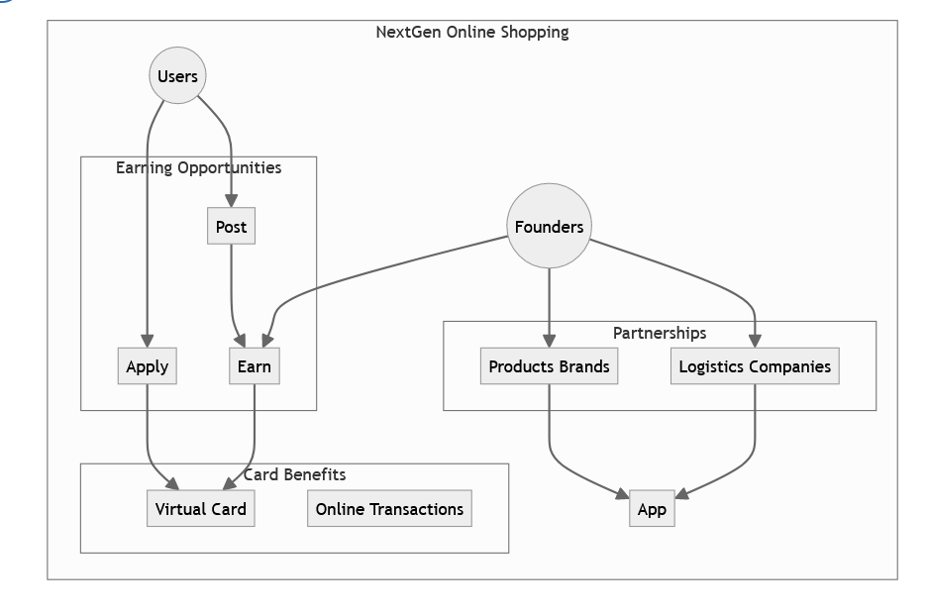

Fig: Use Case Diagram

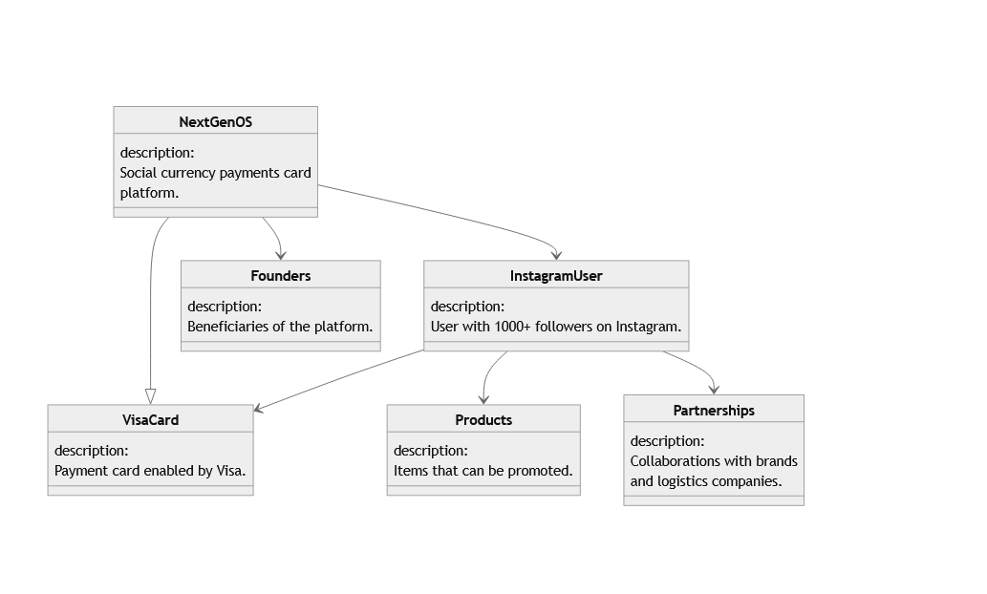

Fig: Class Diagram

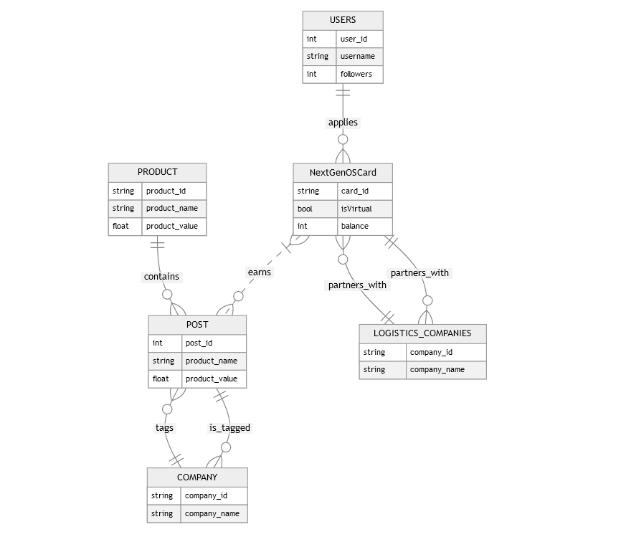

Fig: E-R Diagram

## Data Dictionary

|  |  |  |  |  |
| --- | --- | --- | --- | --- |
| Entity | Attribute | Type/Size | Validation | Key |
| Admin | AdminID | Char(8) | 100-999 | Primary |
| Admin | AdminPass | Char(20) | Valid Password | Primary |
| User | UserID | Char(8) | 1000-9999 | Primary |
| User | UserName | Char() | Required |  |
| User | UserPass | Char(10) | Valid Password | Primary |
| User | UserInstaID | Char() | Valid ID |  |
| Company | CompanyID | Char(8) | 1000-9999 | Primary |
| Company | CompanyName | Char() | Required |  |
| Company | CompanyPass | Char(10) | Valid Password | Primay |
| Brand Promoters | BPID | Char(8) | 1000-9999 | Primary |
| Brand Promoters | BPPass | Char(10) | Valid Password | Primary |
| Brand Promoters | BPName | Char() | Required |  |

## UI/UX Design Specification

